**KAAN FURKAN ALTINOK EE446 - PRE WORK 2**

**Datapath Design**

I haven’t designed a signed arithmetic logic processor but an unsigned one.

Below my overall datapath can be seen including multiplication and division unit with control unit.

First the operation starts with load operation. Consecutive 2 load operations fill the registers with data. After it if a compute signal arrives control unit produces required control signals to execute the operation with 3bit op code.

As multiplication unit I used SHIFT AND ADD algorithm. I took it from the lecture notes. Its operation can be seen in the figure below.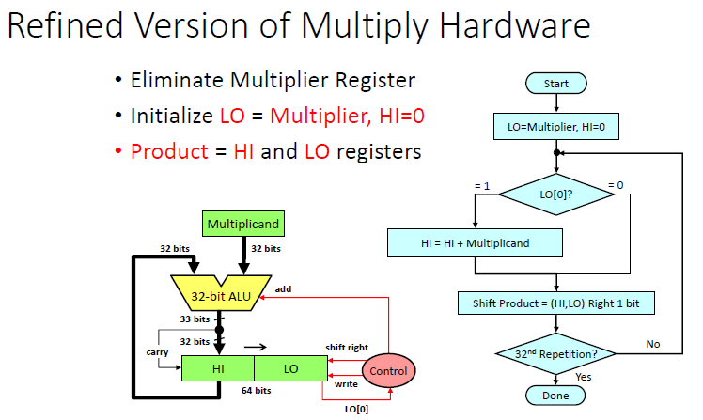

Controller has a new signal which is the last bit of shifted multiplier. It decides whether to add the multiplicand or not by shifting right.

To make it signed it should look to last bits of multiplier and multiplicand. The negative ones should be complemented and the result I again complemented if its sign should be changed.

As division unit I used restoring division algorithm. Its operation can be seen in figure below.

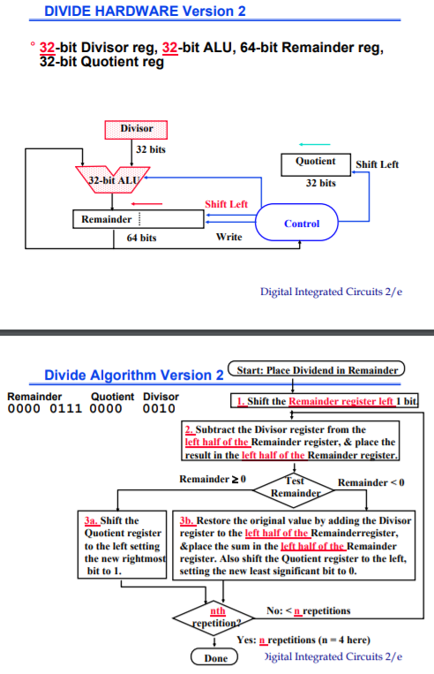

Controller has a new signal that should shift left the quotient register and write the result back to original register.

My control signal can be seen in figure below.

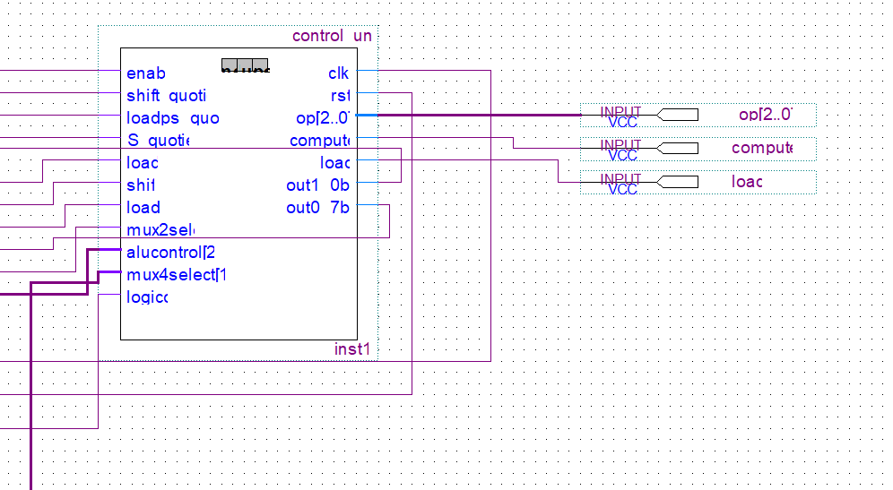

My datapath design together with controller unit can be seen in figure below.

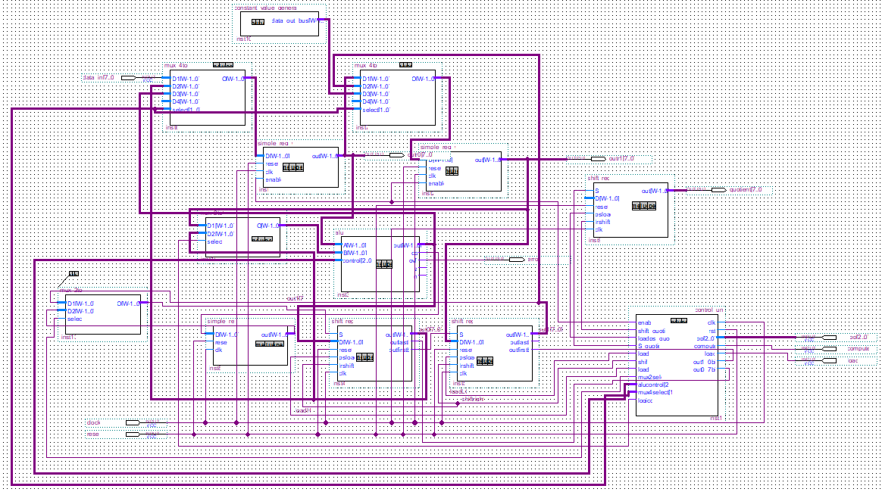

Also, the overall datapath can be seen as a module in figure below.

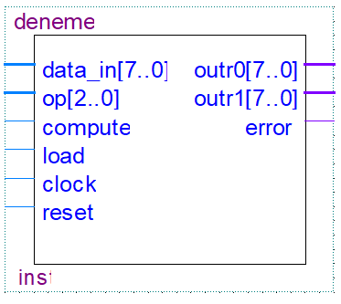

**Controller Design**

Controller Unit as a black-box can be seen in figure below.



ASM charts can be seen below.











HI and LO are two 8bit shift registers. Quotient is another register. Its result is written back to R1.

To handle signed numbers firstly the negative numbers should be converted to positive numbers (By looking the MSB). After conversion the operations is executed. The results can be converted to negative if the result is expected to be negative (EXOR inputs of division and multiplication(MSBs), if the result is 1 than the result should be converted to negative).

After compute signal normal ALU operations take 2 cycles. Multiplication takes circa 18 cycles (less if multiplier has less ones). Division takes circa 18 cycles.

My ASM chart has 10 states. Op signal is enough for one cycle. Op signal is not used in algorithms. It is just for setting up the direction of ASM chart.

Controller code can be seen in figure below.

